

**School of electronics engineering (SENSE)**

Fall semester 2021-2022

Project report

On

**EGC signal analysis using continuous wavelet transformation and deep neural network**

**ECE3501- Digital signal processing**

**Slot:- L45+L46**

Submitted to

Prof. **MALAYA KUMAR HOTA** sir

**Group members:-**

|  |  |  |
| --- | --- | --- |
| **S.NO** | **NAME** | **REG NO** |
| 1 | B.BHARGAV REDDY | 19BEC0802 |
| 2 | SAI SHIVA RAMA KRISHNA | 19BEC0097 |
| 3 | SHAHUKARI CHETAN | 19BEC0058 |

**Content:-**

**Serial number Topic**

1. Certificate
2. Abstract
3. Introduction
4. Literature Review
5. Block diagram
6. ECG signal classification
   1. ARR: Arrhythmias
   2. CHF: Congestive heart failure
   3. NSR: Normal sinus Rhythm
7. Continuous wavelet transform [CWT]
8. Deep neural network
   1. Alex neural network
   2. Multi-Layer Perceptrons (MLP)
   3. Convolution neural network
   4. Recurrent neural network
9. Methodology
   1. Database creation
   2. ECG to image convertor using CWT
   3. ECG signal classification using deep neural network
10. codes
    1. To generate the folders for the different ECG signals
    2. To put signal into there respective folder
    3. To find the accuracy using deep neural network [ALEX-NET]
11. Result
    1. accuracy and loss of the ECG signals
    2. confusion matrix
12. Accuracy measurement
13. Training Progress of the Signals:
14. Conclusion
15. References
16. **Certificate:-**

This is to certify that the project work entitled “ECG signal analysis using CWT and deep neural network”that is being submitted by B.Bhargav reddy (19BEC0802) , shiva (19BEC0097), chetan (19BEC0858) the course ECE2006: DIGITAL SIGNAL PROCESSING (DSP) is a record of bonafide work done under the supervision of MALAYA KUMAR HOTA sir

Prof . signature student sign

1. **Abstract**

The aim of this study is to develop an algorithm to detect and classify the types of electrocardiogram (ECG) signal beats By using Continuous Wavelet Transform (CWT) & Deep Neural Network. The goal is to train a CNN to distinguish Between ARR, CHF and NSR.

Early detection of arrhythmia and effective treatment can prevent deaths caused by cardiovascular disease (CVD). In clinical practice, the diagnosis is made by checking the electrocardiogram (ECG) beat-by-beat, but this is usually time-consuming and laborious. In the report, we propose an automatic ECG classification method based on Continuous Wavelet Transform (CWT) and Convolutional Neural Network (CNN). CWT is used to decompose ECG signals to obtain different time-frequency components, and CNN is used to extract features from the 2D-scalogram composed of the above time-frequency components. Considering the surrounding R peak interval (also called RR interval) is also useful for the diagnosis of arrhythmia, four RR interval features are extracted and combined with the CNN features to input into a fully connected layer for ECG classification. By testing in the MIT-BIH arrhythmia database, our method achieves an overall performance of 70.75%, 67.47%, 68.76%, and 98.74% for positive predictive value, sensitivity, F1-score, and accuracy, respectively. Compared with existing methods, the overall F1-score of our method is increased by 4.75~16.85%. Because our method is simple and highly accurate, it can potentially be used as a clinical auxiliary diagnostic tool.

1. **Introduction**

Arrhythmia refers to irregular heart rhythm and is one of the main causes of cardio vascular disease (CVD) death. Most arrhythmias are not serious, but some are harmful or even life-threatening. For example, atrial fibrillation can lead to strokes and cardiac arrest. It is very dangerous and needs to be treated immediately. According to the World Health Organization (WHO) report, CVD caused approximately 17.5 million deaths in 2012, accounting for 30% of global deaths. By 2030, the number of CVD deaths is expected to increase to 23 million. Furthermore, the cost of CVD-related treatments, including medication, is very expensive. It is estimated that the cost in low- and middle-income countries is approximately US $3.8 trillion from 2011 to 2025.

To this end, researchers have developed a method to automatically classify heartbeats in ECG signals. Most methods consist of feature extraction and classification. The heartbeat morphological and RR interval features are usually used. For classification, different algorithms have been used, including artificial neural networks (ANNs), deep neural network, Continuous wavelet transformation. Despite the good performance achieved by these methods, the ECG waves and their morphological characteristics of different patients have significant variations, and for the same patient, the ECG waves at different times are also different. The fixed features used in these methods are not enough to accurately distinguish arrhythmia of different patients. Recently, with the rapid development of deep neural networks, deep learning-based methods have attracted more and more attention. Deep learning, as a representation learning method, can automatically extract discriminant features from the training data. Several studies show that deep learning-based methods can extract more abstract features and resolve variations between patients in ECG classification.

As there are the different type of the frequency in the ECG signal so that it will be the difficult to classify the different signal of the ECG so that it will increase the difficulty if we use the basic deep neural networking for the extraction. A naturally conceivable way is to transform the ECG signal to time-frequency domain to avoid the effects of aliasing of different frequencies components.There are two widely used time frequency techniques they are Wavelet Transform (WT) and Short-Time Fourier Transform (STFT) . WT was taken from the idea of STFT, but unlike STFT, WT can not only provide high-frequency resolution and low time resolution at low frequencies, but also have high time resolution and low-frequency resolution at high frequencies. Generally, WT can obtain better time-frequency domain analysis results than STFT.

we develop an automatic ECG classification method based on Continuous Wavelet Transform (CWT) and Convolutional Neural Network (CNN) for ECG classification, where CWT refers to WT using continuous wavelet function. CNN is a deep learning method that imitates the human visual system, which has been successfully used for image classification. The CWT is used to transform the ECG heartbeat signal to the time-frequency domain and CNN is used to extract features from the 2D scalogram composed by the above-decomposed time-frequency components. The method has combined the capabilities of CWT in multi-dimensional signal processing and CNN in image feature extraction. To makes full use of all information for ECG classification, the RR interval features are also extracted and fused into our CNN.

1. . **Literature Review**

Over the past two decades, many automatic ECG classification methods have been proposed. So in this I have been selected the journal that are been used to classify the different types of the ECG signal and In this they have been used the CNN neural network.

1. **Block diagram**

SIGNAL FILTER

SAMPLE SELECTION

ARR

FEATURE EXTRACTION OF CWT

DEEP NEURAL NETWORK [ALEX-NET]

CHF

NSR

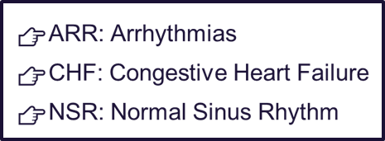

1. **ECG signal classification**

There are different types of the ECG signals and in this project we are been mainly use the following ECG signals like for the classification they are mainly.

ARR: Arrhythmias

CHF: Congestive Heart Failure

NSR: Normal Sinus Rhythm

**6.1 Arrhythmias**:- An arrhythmia is a problem with the rate or rhythm of the heartbeat. During an arrhythmia, the heart can beat too fast, too slowly, or with an irregular rhythm. When a heart beats too fast, the condition is called tachycardia. When a heart beats too slowly, the condition is called bradycardia.

**6.2 Congestive heart failure**:- Heart failure can occur if the heart cannot pump (systolic) or fill (diastolic) adequately . Symptoms include shortness of breath, fatigue, swollen legs and rapid heartbeat. Treatments can include eating less salt, limiting fluid intake and taking prescription medication. In some cases a defibrillator or pacemaker may be implanted

**6.3 Normal sinus rhythm**:- Normal sinus rhythm (NSR) is the rhythm that originates from the sinus node and describes the characteristic rhythm of the healthy human heart. The rate in NSR is generally regular but will vary depending on autonomic inputs into the sinus node.

So we used to use all this three type of the ECG signals and we used to classify them using CWT and get there accuracy by the help of the deep neural network.

1. **Continuous wavelet transform [CWT]**

The continuous wavelet transform - mathematical and signal processing tool primarily aimed for image compression, image denoising, etc. Used in many other fields such as Biomedical Signal processing, namely ECG and EEG analysis, Financial Time Series Analysis, Partial Differential equations solving, etc. Coefficients directly fed into the input layer of the convolutional neural networks as an ‘image’ in effect creating a “Transfer learning’ scenario. In this work we have used only Mortlet Wavelet.

1. **Deep neural network**

**Deep Neural Network** have been widely applied in various areas such as pattern recognition, natural language processing, and computational learning. During the past decades, machine learning has brought enormous influence on our daily life with examples including efficient web search, self-driving systems, computer vision, and optical character recognition. Especially, deep neural network models have become a powerful tool of machine learning and artificial intelligence. A deep neural network (DNN) is an artificial neural network (ANN) with multiple layers between the input and output layers. The success of deep neural networks has led to breakthroughs such as reducing word error rates in speech recognition by 30% over traditional approaches (the biggest gain in 20 years) or drastically cutting the error rate in an image recognition competition since 2011 (from 26% to 3.5% while humans achieve 5%).

**So in this project we use the ”ALEX” neural network for the image processing of the different signals.**

**8.1 Alex neural network:-**

Alex neural network was one of the image net large-scale visual recognition that are used to recognize the all the different images with the different frequency. The Alexnet has eight layers with learnable parameters. The model consists of five layers with a combination of max pooling followed by 3 fully connected layers and they use Relu activation in each of these layers except the output layer. They found out that using the relu as an activation function accelerated the speed of the training process by almost six times. They also used the dropout layers, that prevented their model from over fitting. Further, the model is trained on the Image net dataset. The Image net dataset has almost 14 million images across a thousand classes. So it have the all the things that are been present in the alex neural network so we have been chosen this type of the alex neural network for the different types of the ECG signals.

**There are three types which are been mainly used in the all the neural network that are been used:-**

* 1. Multi-Layer Perceptrons (MLP)

8.3 Convolutional Neural Networks (CNN)

8.4 Recurrent Neural Networks (RNN)

**8.2 Multi-neural network**

A multilayer perceptron (MLP) is a class of feed forward artificial neural network (ANN). An MLP consists of at least three layers of nodes: an input layer, a hidden layer and an output layer. Except for the input nodes, each node is a neuron that uses a nonlinear activation function. And this is the one of the best neural network so this is been used in the most of the developers.

**8.3 Convolutional neural network [CNN]**

A convolutional neural network (CNN) is a type of artificial neural network used in image recognition and processing that is specifically designed to process pixel data. CNNs are powerful image processing, artificial intelligence (AI) that use deep learning often using machine vison that includes image and video recognition, along with recommender systems and natural language processing (NLP).

A CNN uses a system much like a multilayer perceptron that has been designed for reduced processing requirements. The layers of a CNN consist of an input layer, an output layer and a hidden layer that includes multiple convolutional layers, pooling layers, fully connected layers and normalization layers. The removal of limitations and increase in efficiency for image processing results in a system that is far more effective, simpler to trains limited for image processing and natural language processing

**8.4 Recurrent Neural Networks**

Recurrent neural networks (RNN) are the state of the art algorithm for sequential data and are used by Apple's Siri and and Google's voice search. It is the first algorithm that remembers its input, due to an internal memory, which makes it perfectly suited for machine learning problems that involve sequential data. It is one of the algorithms behind the scenes of the amazing achievements seen in deep learning over the past few years. In this post, we'll cover the basic concepts of how recurrent neural networks work, what the biggest issues are and how to solve them

1. **Methodology**

The main aim of this project was to classify the different type of the ECG signals using the continuous wavelet transformation [CWT] and we used to create the 2D-scalogram composed waveform of that different frequency and then by the help of the deep neural network we used to generate the final waveform of the all types of the ECG signal that which are been mainly used to give the “efficiency” and “accuracy” of the different ECG signals.

**9.1 Database creation**

We have been taken this data from the MIT-BIH and we have mainly have different type of recordings that are been taken from the different MIT-BIH database.

These signals are obtained from 162 ECG recordings from three PhysioNet databases:

* MIT-BIH Arrhythmia Database (96 Recordings) [ARR Signals]
* MIT-BIH Normal Sinus Rhythm Database (30 Recordings) [NSR Signals] and
* BIDMC Congestive Heart Failure Database (36 Recordings) [CHF Signals].

And we used to store the all the above data into the matrix form like 162x65536 and it used to carry the 162 samples of the ECG signal and it have the size of the 65536 samples each so to place the 162 sample we used to give the order of the ECG signals as follow 1:96 are ARR signal (96) , 97:126 are CHF signal (30) and 127:162 are NSR signal (36) .

So we have unequal number of dataset so we use to pre-process the database. In this we have the 65536 samples from that we used to broken that samples into the small signals of the length 500 samples each to increase the database and also make to get the appropriate value for the CNN so for that

* We take 30 recordings of each type (ARR, CHF, NSR) to have equal distribution.
* Each recording is broken in to 10 pieces of length of 500 samples.
* Therefore, each category will provide 300 recordings of size 500 samples and total will be 900 recordings.
* Out of 900 recordings, 750 will be used for training and 150 will be used for testing.

So that at the final we used to have the different type of ECG signals with the sample sampling level and final we have the 900 recordings which are been used for the classification using CWT.

**9.2 ECG Signals to Image conversion using CWT**

As the ECG signal is composed of different frequency components, in this we transform the ECG signal to the time-frequency domain to facilitate feature extraction. CWT is the most commonly used time-frequency analysis tool, which uses a family of wavelet functions to decompose a signal in the time-frequency domain. So by the CWT we used to get the 2D-scalogram composed waveform of the all types of the ECG signal.

So in this we mainly use the CWT and that are been used to have the following parameters which are used to classify the different types of the ECG signals they are

* We mainly use the Wavelet is ‘Analytic Morlet (amor)’.
* This wavelet has equal variance in time and frequency.
* Analytic wavelets are wavelets with one-sided spectra, and are complex valued in the time domain.
* These wavelets are a-good-choice for obtaining a time-frequency-analysis using the CWT.
* 12 wavelet band-pass filters per octave (12 voices per octave) are used for CWT

Then by the help of the all feature that are been provided by the CWT we used to generate the scologram images of the all the ECG signals that are been provided in the database. So the CWT used to convert the each 1D signal of the ECG signals into the CWT scalogram and that each Scalogram are used to represent by the color-map of the jet of 128 colors. So to classify them we used to generate the different folders corresponding to the each type of the ECG signal so then after conversion we used to have the total of the 900 different 2d-scalogram images of the different ECG signals like ARR,CHF, and NSR. .

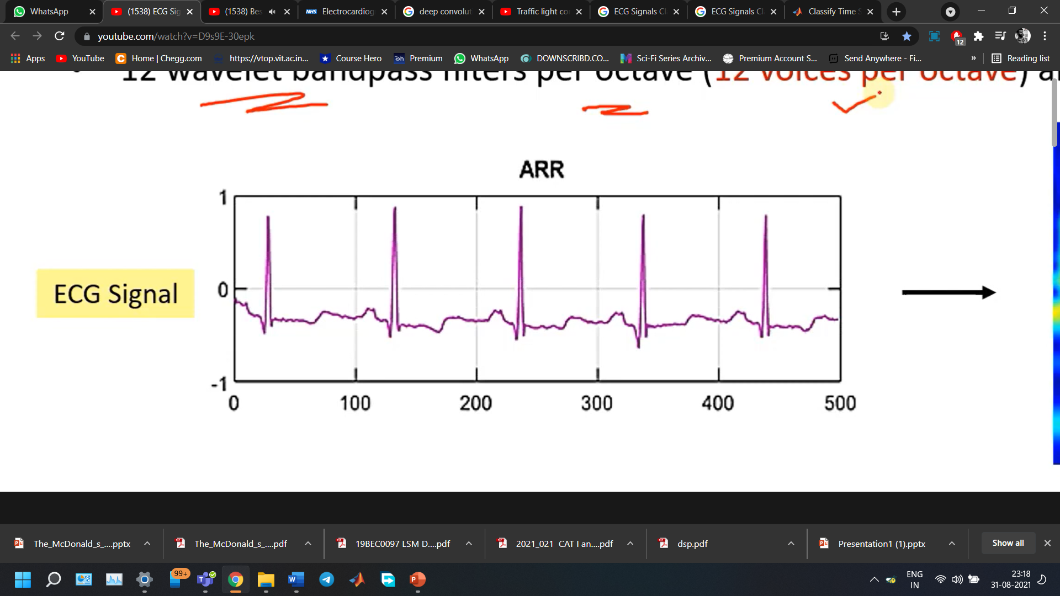 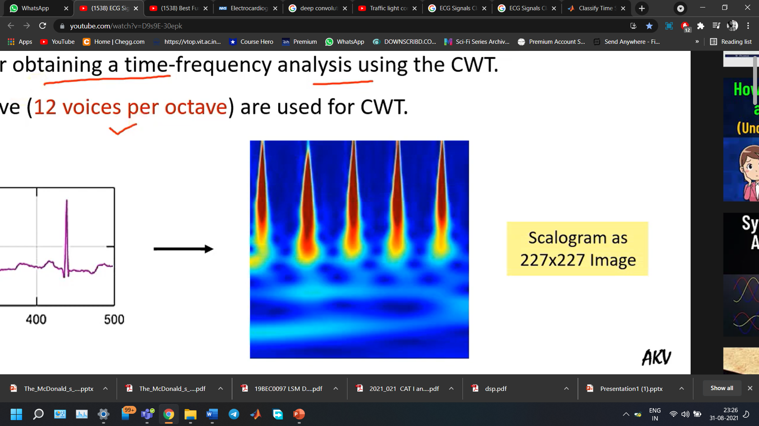

 

**9.3 ECG signal classification using neural network**

A deep neural network is a neural network with a certain level of complexity, a neural network with more than two layers. Deep neural networks use sophisticated mathematical modeling to process data in complex ways. So in this by the help of the “ALEX” neural network we used to find the accuracy of the all the types of the neural network that are been present in the ECG database. AlexNet was a deep neural network that was developed by Alex Krizhevsky. It was designed to classify images for the ImageNet LSVRC-2010 competition, where it achieved state of the art results. It also worked with multiple GPUs

AlexNet was much larger than previous CNNs used for computer vision tasks. It has 60 million parameters and 650,000 neurons and took five to six days to train on two GTX 580 3GB GPUs. Today there are much more complex CNNs that can run on faster GPUs very efficiently even on very large datasets. Multiple Convolutional Kernels extract interesting features in an image. In a single convolutional layer, there are usually many kernels of the same size.

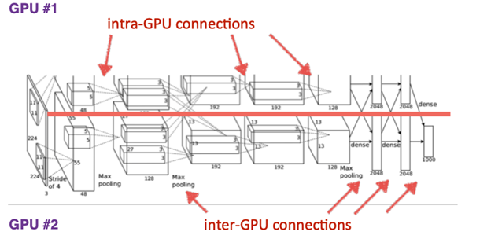

The first two Convolutional layers are followed by the Overlapping Max Pooling layers that we describe next. The third, fourth and fifth convolutional layers are connected directly. The fifth convolutional layer is followed by an Overlapping Max Pooling layer, the output of which goes into a series of two fully connected layers. The second fully connected layer feeds into a softmax classifier with 1000 class labels.

So all the things that are been mentioned are the operation that are been done in the alex neural network and then we used to this type of the alexnet for your ECG signals to get the accuracy of the different types of the ECG signals images that are been present in the database. So as we know that the alexnet are been used to get the images as the input so it take the 900 images of the different types of the ECG signal and then it used to generate what is the certain accuracy of the all ECG signals that are been present so this used to help the people to able to detect whether the people is good or else there are been suffering with the heart diseases.

1. **Code’s**

**10.1 To generate the folders for the different types of the ECG signal**

clc;

close all;

clear all;

%program to create the CWT image database from ECG signal

load('ECGData.mat'); %to open the ECG database

data=ECGData.Data; %getting Database

labels = ECGData.Labels; %getting lable

ARR=data(1:30,:); %taking first 30 recording of ARR

CHF=data(97:126,:); %taking first 30 recording of CHF

NSR=data(127:156,:); %taking first 30 recording of NSR

signallenght=500;

%Defining filters for CWT with amot wavelet and 12 filter per octave

fb=cwtfilterbank('SignalLength',signallenght,'wavelet','amor','VoicesPerOctave',12);

%making folder

mkdir('ecgdataset'); %main folder

mkdir('ecgdataset/arr'); %sub folder

mkdir('ecgdataset/chf'); %sub folder

mkdir('ecgdataset/nsr'); %sub folder

ecgtype={'ARR', 'CHF', 'NSR'};

%function to convert ECG to images

ecg2cwtscg(ARR,fb,ecgtype{1});

ecg2cwtscg(CHF,fb,ecgtype{2});

ecg2cwtscg(NSR,fb,ecgtype{3});

**10.2 To put signal into there respective folder**

function ecg2cwtscg(ecgdata,cwtfb,ecgtype) %to create your own function

nos=10; %number of signals

no1=500; %number of signal length

colormap=jet(128);

if ecgtype=='ARR'

folderpath=strcat('MATLAB Drive/ecgdataset/arr/');%to store the data in perticular folder

findx=0;

for i=1:30

indx=0;

for k=1:nos

ecgsignal=ecgdata(i,indx+1:indx+no1);

cfs = abs(cwtfb.wt(ecgsignal));

im=ind2rgb(im2unit8(rescale(cfs)),colormap);

filenameindex=findx+k;

filename=strcat(folderpath,sprintf('%d.jpg',filenameindex));

imwrite(imresize(im,[227 227],filename));

indx=indx+no1;

end

findx=findx+nos;

end

elseif ecgtype=='CHF'

folderpath=strcat('MATLAB Drive/ecgdataset/chf/');%to store the data in perticular folder

findx=0;

for i=1:30

indx=0;

for k=1:nos

ecgsignal=ecgdata(i,indx+1:indx+no1);

cfs = abs(cwtfb.wt(ecgsignal));

im = ind2rgb(im2unit8(rescale(cfs)),colormap);

filenameindex=findx+k;

filename=strcat(folderpath,sprintf('%d.jpg',filenameindex));

imwrite(imresize(im,[227 227],filename));

indx=indx+no1;

end

findx=findx+nos;

end

elseif ecgtype=='NSR'

folderpath=strcat('MATLAB Drive/ecgdataset/arr/nsr/');%to store the data in perticular folder

findx=0;

for i=1:30

indx=0;

for k=1:nos

ecgsignal=ecgdata(i,indx+1:indx+no1);

cfs = abs(cwtfb.wt(ecgsignal));

im = ind2rgb(im2unit8(rescale(cfs)),colormap);

filenameindex=findx+k;

filename=strcat(folderpath,sprintf('%d.jpg',filenameindex));

imwrite(imresize(im,[227 227],filename));

indx=indx+no1;

end

findx=findx+nos;

end

end

**10.3 To find the accuracy using deep neural network [ALEX-NET]**

clc;

clear all;

close all;

%Training and Validation using Alexnet

DatasetPath='/MATLAB Drive/Examples/dsp project/Copy_of_ecgdataset/dsp project';

%Reading Images from Image Database Folder

images = imageDatastore(DatasetPath,'IncludeSubfolders', true,'Labelsource', 'foldernames');

%Distributing Images in the set of Training and Testing

numTrainFiles = 250;

[TrainImages, TestImages] = splitEachLabel(images, numTrainFiles, 'randomize');

net = alexnet; %importing pretrained Alexnet (Requires support package)

layersTransfer = net.Layers (1:end-3);% "Preserving all layers except last three

numClasses =3; %Number of output classes: ARR, CHF, NSR

%Defining layers of Alexnet

layers=[

layersTransfer

fullyConnectedLayer(numClasses,'WeightLearnRateFactor',20, 'BiasLearnRateFactor',20)

softmaxLayer

classificationLayer];

options = trainingOptions('sgdm','MiniBatchSize',20,'MaxEpochs',8,'InitialLearnRate',1e-4,'Shuffle','every-epoch','ValidationData',TestImages,'ValidationFrequency', 10, 'verbose',false,'plots','training-progress');

%Training the AlexNet

netTransfer = trainNetwork(TrainImages, layers, options);

%Classifying Images

YPred = classify(netTransfer,TestImages);

YValidation = TestImages.Labels;

accuracy = sum(YPred == YValidation)/numel (YValidation);

%Plotting Contuation Matrix

plotconfusion (YValidation, YPred)

1. **Results**

**11.1 Accuracy and loss of the ECG signal**

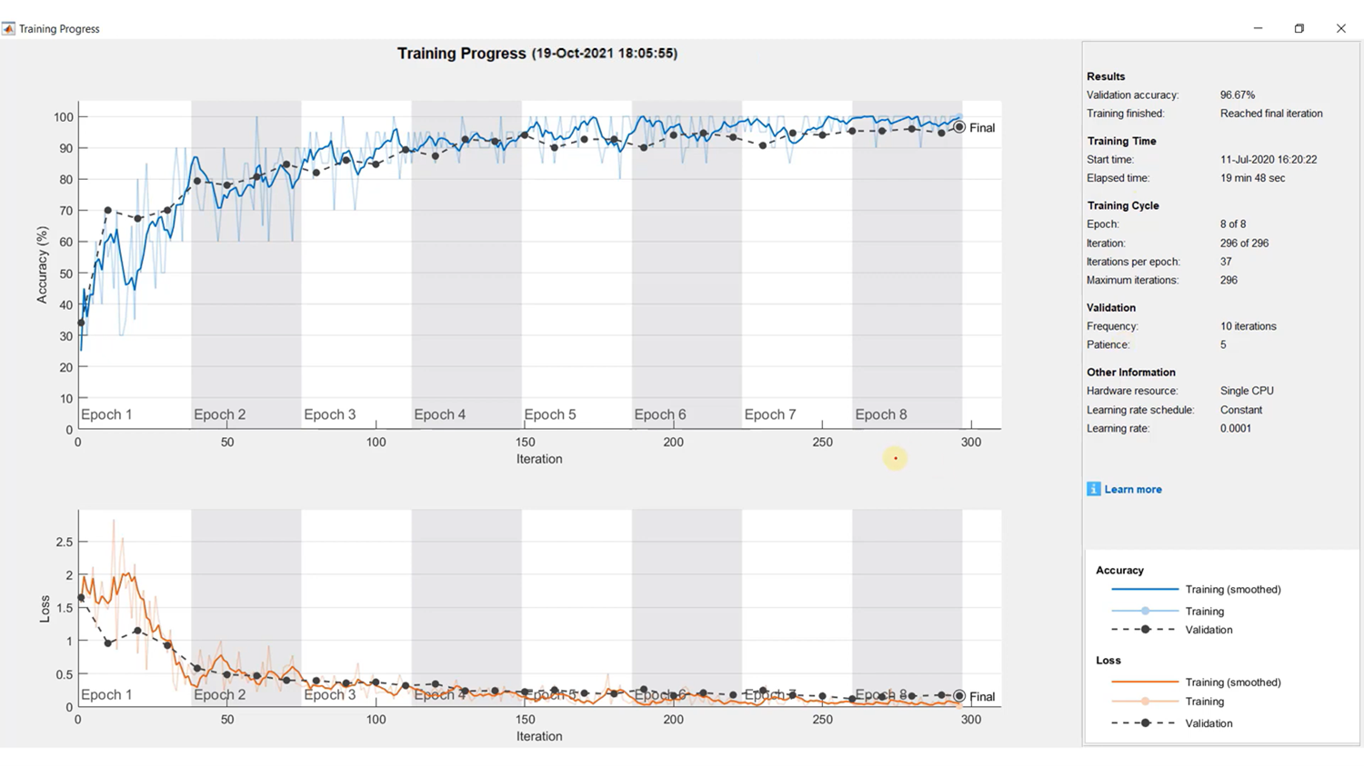

**11.2 confusion matrix**

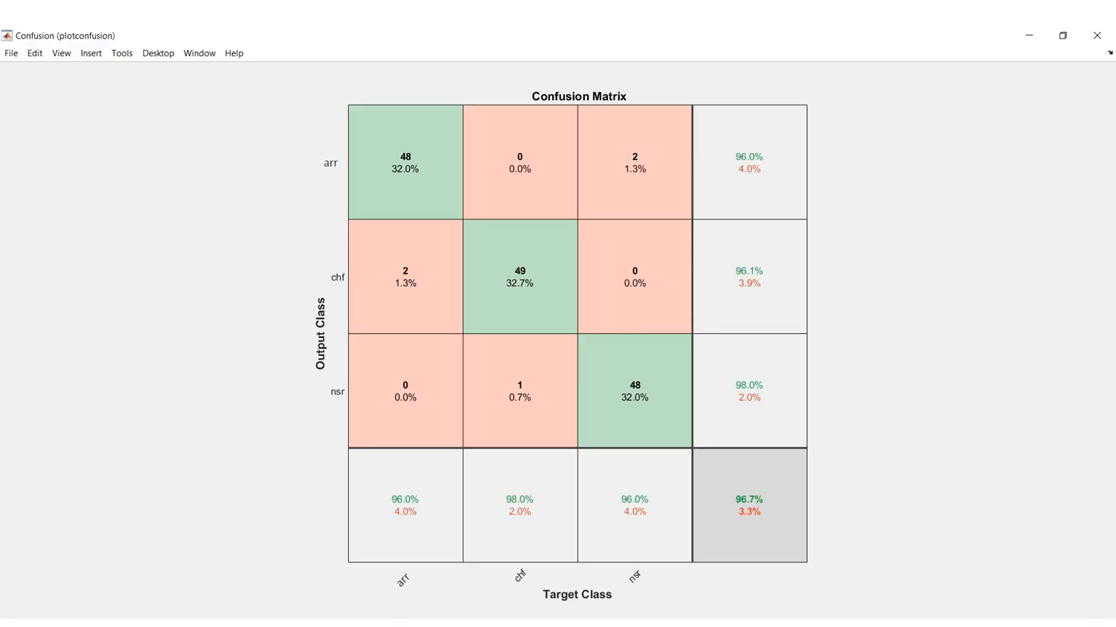

1. **Accuracy measurement**

An electrocardiogram (ECG) might be utilized to analyze arrhythmia(ARR). It is a perusing of pulse and mood. Congestive heart disappointment (CHF) is a clinical disorder wherein the heart neglects to siphon blood at the rate required by the using tissues or in which the heart can do as such just with a height in filling weight. NSR used to mean a particular kind of sinus musicality where every single other estimation on the ECG additionally fall inside assigned ordinary breaking points

1. **Training Progress of the Signals:**

So in this we used to get the output as the accuracy of the 96.67% and we used to predict them by using the 900 different types of the ECG images that are been used to give this much amount of the accuracy and in this they are mainly 750 images are considered for training and 150 images are been used for the testing and we used to have the confusion matrix in that we used to have the separate accuracy value for the different ECG signals and we used to get the error values for the different ECG signals that are been present in the database.

1. **Conclusion**

We developed a novel ECG classification method based on CWT and deep neural network. To avoid the effects of aliasing of different frequency components, CWT is first used to transform the ECG heartbeat signal into the time-frequency domain. Then, alexnet is used to extract features from a scalogram composed by decomposed time-frequency components. The method can make full use of the advantages of CWT in multi-dimensional signal processing and alexnet in image recognition. By testing it on the MIT-BIH arrhythmia database using the inter-patient paradigm,. Due to the highly accurate ECG classification, our method can potentially be used as a clinical auxiliary diagnostic tool. In general, ARR, CHF and NSR, as one of the main causes of cardiovascular disease, is necessary to diagnose it at an early stage. Upon a proper early diagnosis, effective treatment like vagal maneuvers or medications can reduce arrhythmia and avoid cardiovascular disease.

Although good overall performance achieved by our method, So in this we are been using the deep neural network like alexnet so it used to give the maximum accuracy so there are some other neural network which is used to give the more efficiency so we can improve by the help of the other neural network so we can have the still more accuracy value. In general, this can be improved by adding more annotated ECG data. However, labeling ECG heartbeats are very expensive and time consuming. Nowadays, there are many publicly available unlabeled ECG databases, and the use of unsupervised learning such as auto encoder may further improve the performance of the F class in an inexpensive way. In the future, we will try to carry out related work.

1. **Reference**

* Kora, P., Meenakshi, K., & Swaraja, K. (2019). Detection of Cardiac Arrhythmia Using Convolutional Neural Network. In Soft Computing and Signal Processing (pp. 519-526). Springer, Singapore
* Kora, P., Annavarapu, A., Yadlapalli, P., Krishna, K. S. R., & Somalaraju, V. (2017). ECG based atrial fibrillation detection using sequency ordered complex Hadamard transform and hybrid firefly algorithm. Engineering Science and Technology, an International Journal, 20(3), 1084-1091.
* Kora, P., & Krishna, K. S. R. (2016). ECG based heart arrhythmia detection using wavelet coherence and bat algorithm. Sensing and Imaging, 17(1), 12.
* Padmavathi, K., & Ramakrishna, K. S. (2015). Detection of Atrial Fibrillation using Autoregressive modeling. International Journal of Electrical and Computer Engineering (IJECE), 5(1), 64-70.
* Padmavathi, K., & Ramakrishna, K. S. (2015). Detection of atrial fibrillation using continuous wavelet transform and wavelet coherence. International Journal of Systems, Control and Communications, 6(4), 292-304.
* Padmavathi, K., & Krishna, K. S. R. (2014, November). Myocardial infarction detection using magnitude squared coherence and support vector machine. In 2014 International Conference on Medical Imaging, m-Health and Emerging Communication Systems (MedCom) (pp. 382-385). IEEE.
* Majnaric L, Sabanovic S. “Cardiovascular disease research by using data from electronic health records”. Atherosclerosis, 252:e41-e41.2016.
* D. Zhang, "Wavelet approach for ECG benchmark meander adjustment and clamor decrease", in Proc. IEEE Int. Eng. Prescription. Biol. Soc, pp. 1212-1215. 2005.

**NOTE:-**

As there are different type of neural network. In this project I have been select the “ALEX” neural network to get the accuracy of the all this different types of ECG signals but the journal paper that we have been selected they have been used the “convolution neural network “[CNN]. So in this both cases your final aim is to find the accuracy of the ECG signals that we have been selected.